Rats Above Sea Level Altimeter

How GitHub's Copilot helped clean up a mess.
Feb 25, 2026
•
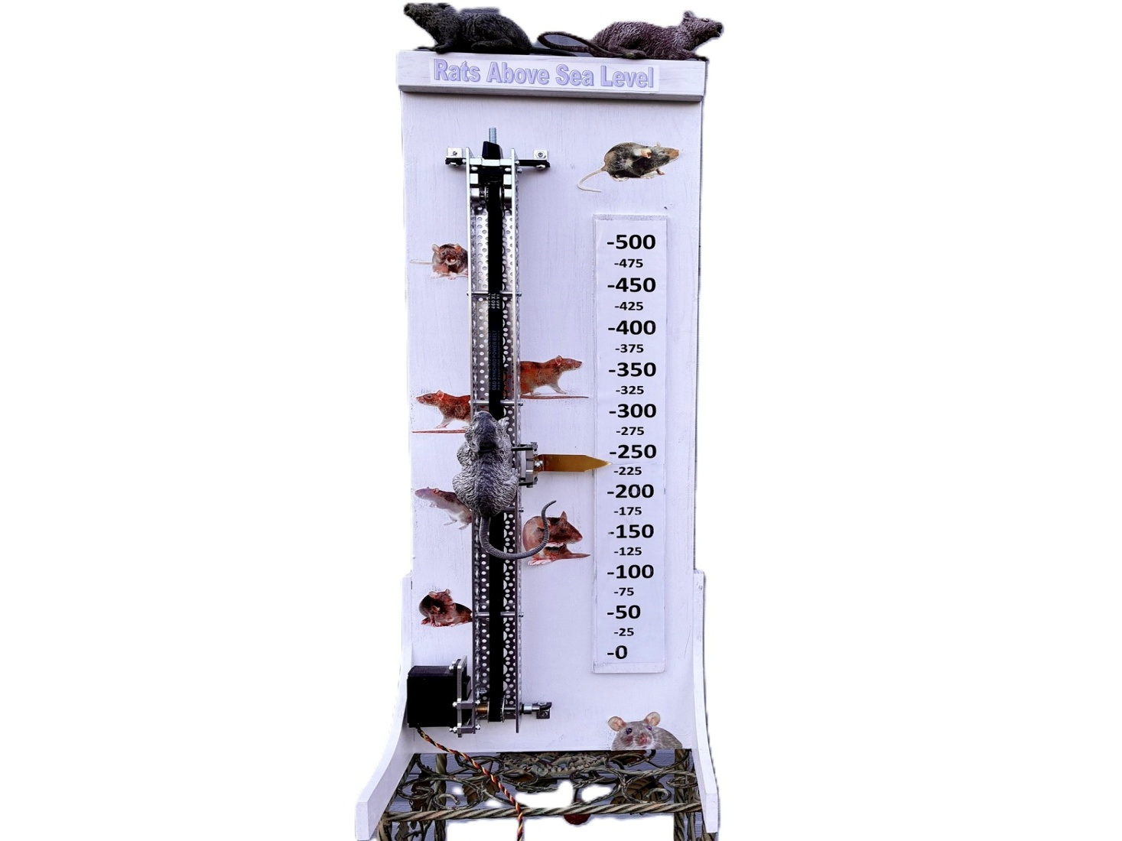
Devices & Components
1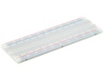
Breadboard - 830 contacts 1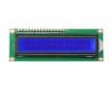16x2 LCD display with I²C interface
1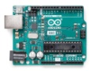
Arduino Uno Rev3 1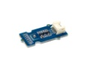Grove - Barometer Sensor (BMP280)
1 servo motor 20Kg 180 deg 1 Battery NiMH 6V, 2.7A-H
Software & Tools Arduino IDE
Project description
Altimeters are not all that common compared to clocks, but they can be lots of fun as well as useful. Rats Above Sea Level is a servo-driven Altimeter that uses a BMP280 sensor.
The project also includes a Dial Altimeter, an ultrasonic sensor, and a LCD display. One of the features of the BMP280 is that if you let it know what ambient sea level barometric pressure is at your location, it will calculate the altitude. You can look up real time sea level barometric pressure for your location on the Internet. I live in Oregon and I use $ this $ . I had previously tried to make an altimeter using a GPS receiver connected to an Arduino, but the accuracy was rible (greater than +/- 10 meters if I recall correctly). 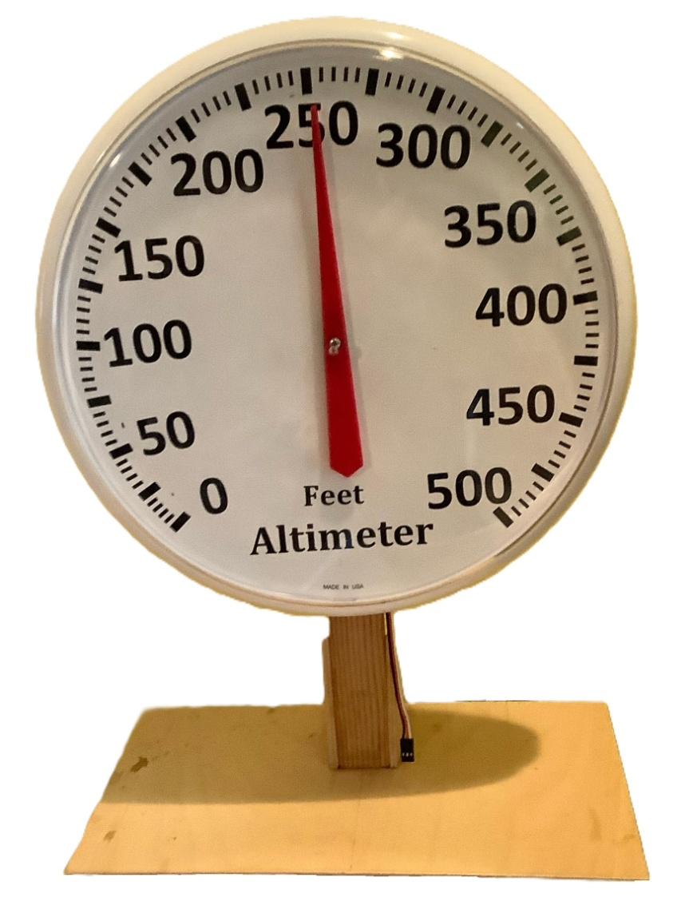
Dial Altimeter
This project started out as a implementation of a Dec 13, 2019 article in Circuit Digest by Manoj Kumar. It used an Arduino Uno and a LCD to display temperature and barometric pressure based on an BMP280 sensor. At some point I added an ultrasonic sensor to calculate and display distance to the nearest person, with a semi-insulting message if someone got closer than 30 cm to the sensor.
I then decided to make a servo motor driven dial altimeter (shown above). Then I saw that Servo City was selling a servo driven slider kit and I decided to use some left-over rubber rats and make an additional altitude display (Rats Above Sea Level). As the project expanded, I just tacked on additional Arduino code to implement the added functions. When I was done, everything worked fine, but the code was a mess.
Arduino code for displaying altitude
The basis of this project is converting the altitude information from the BMP 280 sensor into a PWM drive signal for the servo motors that display altitude. Here, the measured pulse widths for the maximum and minimum slider positions are used to calculate the pulse width for a given altitude.
float LinMin = 820; //pulse width for zero feet on slider
float LinMax = 2200; //pulse witdth for 500 feet on slider
R= (LinMax-LinMin)/500;
LinPW = HEIGHT*R + LinMin;
A similar calculation is performed for the Dial Altimeter pulse width.
Arduino code cleanup with Copilot
I had opened a GitHub account so I could use it for a previous Arduino project so I had a very superficial knowledge of Github. I copied the code to a GitHub repository (Rats Above Sea Level) and asked GitHub CoPilot to clean it up and add it as a branch to the repository. CoPilot did this but it felt it was necessary to point out my shortcomings. What really stung was the "Magic Numbers" category. This was my first programming experience with an AI and it was uncanny; a novice could get useful results!
Here is the summary of the changes that CoPilot proposed to the Arduino program for this project.
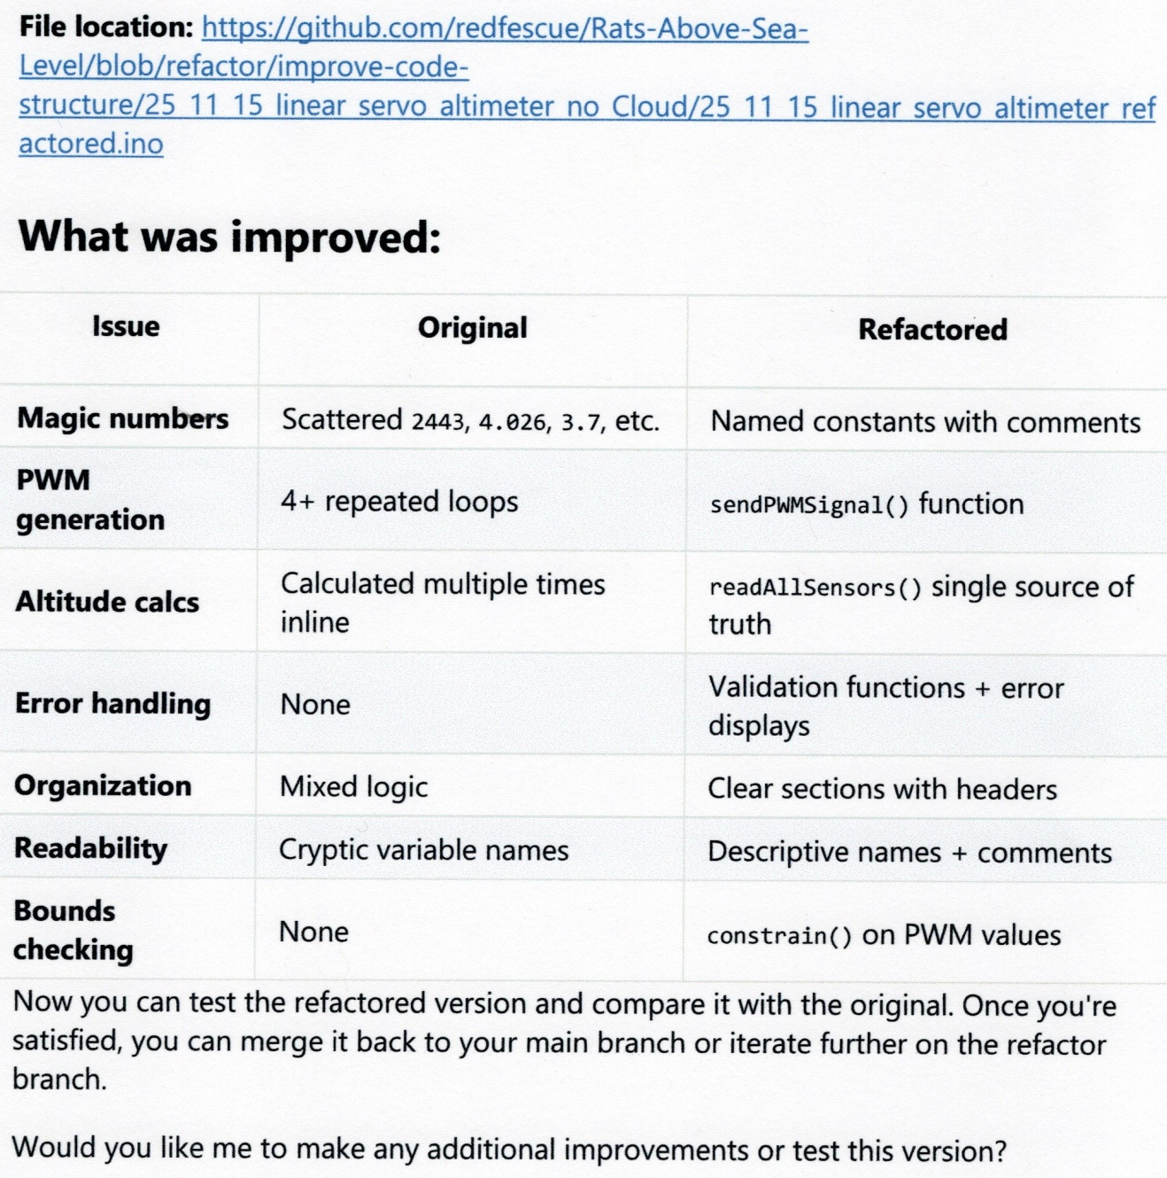
At this point I lost my nerve and didn't ask Copilot for any other involvement. I downloaded the improved program to my machine and tried it out. I worked except for the dial altimeter did not have a full range. This was because the original program didn't have enough information for Copilot to determine the maximum and minimum pulse widths for the dial altimeter. It resorted to "magic numbers" itself. Once I corrected this, the cleaned-up program worked.
I did some more modifications to the program; eliminated some of the error handling, and changed some of the messages. The review is documented in a downloadable file.
Construction The electronics are shown in the photo below. The parts used are listed in the materials section above.
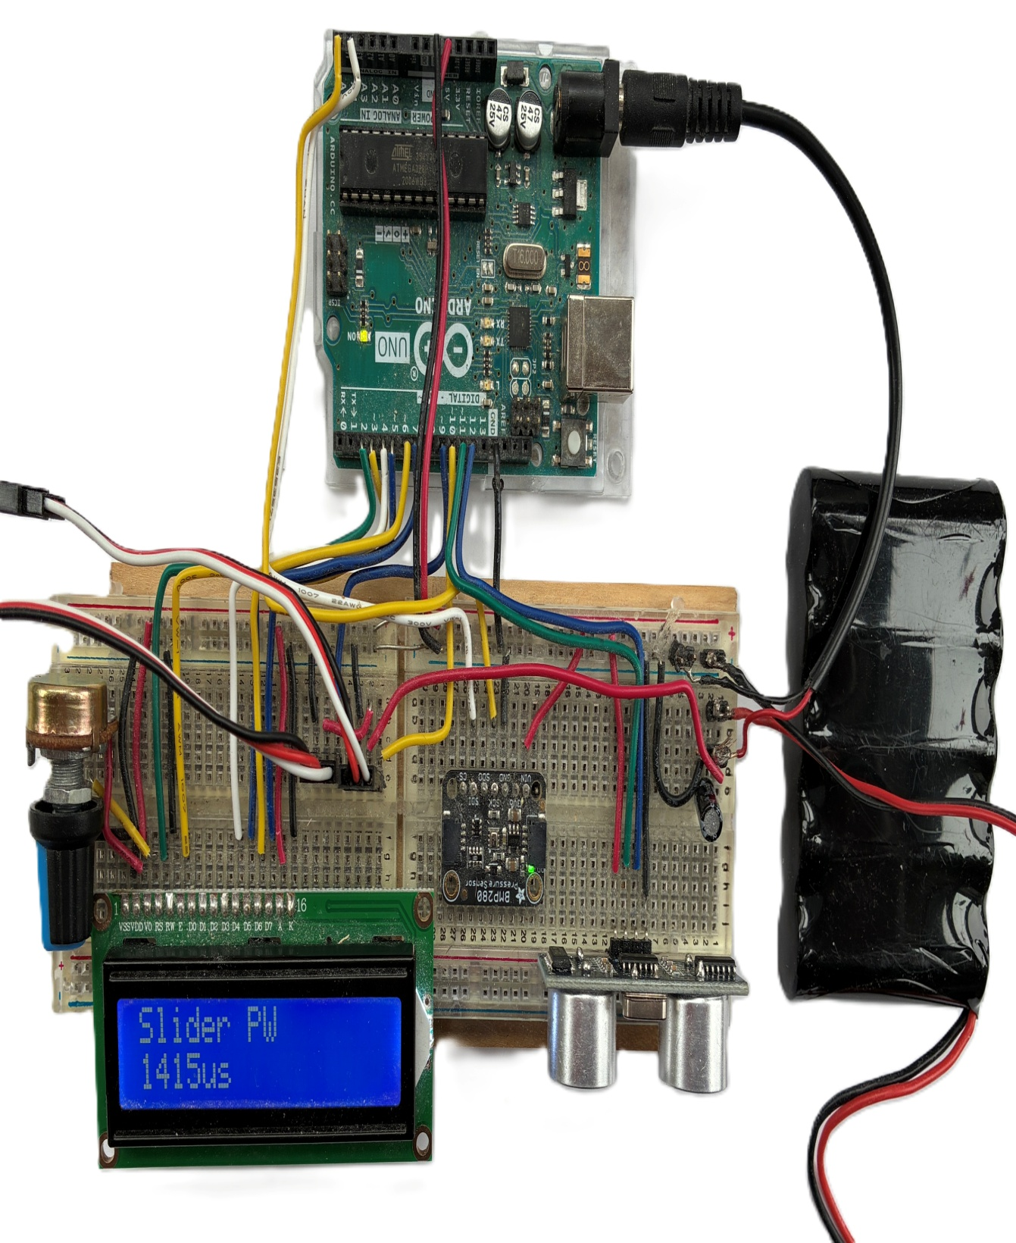
Electronics
The Rats Above Sea Level display is based on a Servo City slider kit (HS-785HB) which has since been discontinued. Worse, many of the parts that make up this kit are discontinued also. It should be possible to implement a slider mechanism using a HS-785HB 5 turn servo, a couple of pinion pulleys, some U-channel, a timing belt, etc.
The Dial Altimeter was constructed using a AcuRite 01360 12.5 inch Dial Thermometer. I removed the temperature scale and re-wrote the units to show feet altitude and attached a servo motor to the back to drive the pointer. Unfortunately, this part is also discontinued. It was ideal since the scale was easy to adapt to altitude. Of course, with a 'little' more work there are many dial thermometers that could be used.
Here is a wiring diagram of the electronics.
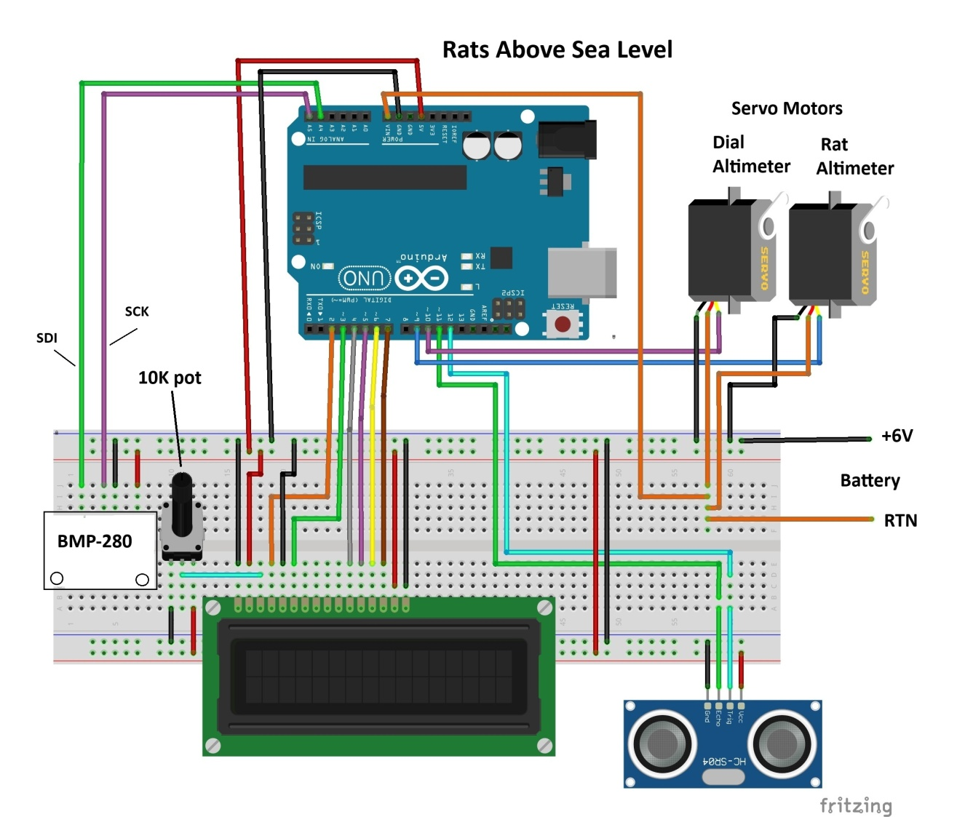
Wiring diagram
This fun project resulted in me having two Arduino-controlled altimeters. The Rats Above Sea Level is especially nice.
Code
Rats above sea level
Before clean-up
redfescue/Rats-Above-Sea-Level

Documents Arduino based altimeter "Rats Above Sea Level"/ Read More

Latest commit to the master branch on 03-07-2026
Download as a zip
Rats above sea level
After clean-up
redfescue/Rats-Above-Sea-Level

Documents Arduino based altimeter "Rats Above Sea Level"/ Read More

Latest commit to the master branch on 03-07-2026
Download as a zip
Downloadable files
Review of refactored program
Fix error, remove unneeded code
https://github.com/redfescue/Rats-Above-Sea-Level/blob/main/Review%20of%20refactored.txt

